

1343 Wantagh Avenue
Wantagh, NY 11793
(516) 679-8299

Confidential Information
Welcome. We want to make your visit as pleasant and comfortable as possible.
If at any time you have any questions or concerns, please let us know.

Name: __________________________________________________________ D.O.B. __________________________
Phone Number #: ___________________ Email: _______________________________
Would you like to receive texts: Y / N Emails: Y / N about upcoming appointments?
If you would like to receive text messages, what cellphone carrier do you use? __________________________________
Street Address_____________________________________________________________________________________
City __________________________________ State __________________________ Zip Code ____________________
Have you received massage therapy before? Y / N - If so what type? Deep tissue? Y / N Swedish? Y / N Other? Y / N
What medication do you take? ________________________________________________________________________
Have you consumed alcohol in the past 24 hours? Y / N
Emergency Contact Name: ________________________ Phone #: __________________ Relationship: ______________
Referred By: ____________________
Do you have a history of any of the following? Please Check
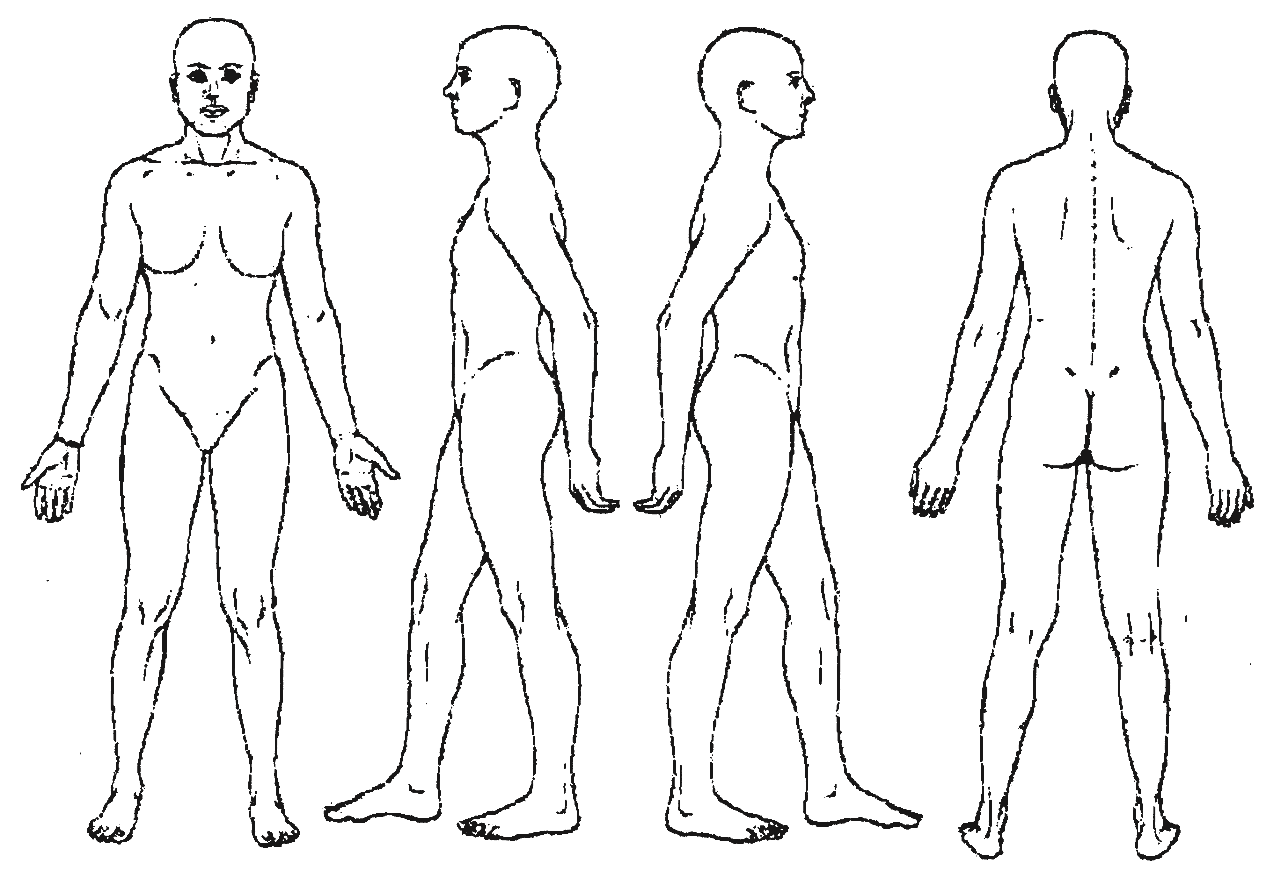
Please Mark Area(s) of Pain
Accidents | Disk Problems | Joint Aches
Headaches | Lower Back Pain | Abdominal Pain
High Blood Pressure | Cancer | Diabetes
Allergies to oils/  perfumes | Wear contacts or other  prosthesis | Decreased Range of  Motion
Stroke | Colitis | Whiplash
Varicose Veins | Heart Attack | Mid Back Pain
Surgery | Seizures | Arthritis, bursitis, gout
Broken Bones | Nervous Tension | Breast augmentation
Neck Pain | Sprains | HIV
Fibromyalgia | T.M.J. | Other
Do you have any of the following today?
Sunburn | Inflammation
Severe Pain | Headache
Open Cuts, bruises, burns | Irritated Skin Rash
Poison Ivy | Cold/Flu
Is there anything else that we should know?
________________________________________________
________________________________________________
________________________________________________

I understand this massage is not a replacement for medical care and that no diagnosis will be made. I am responsible for paying for any appointment cancellation of less than 24 hour. If this office is submitting paperwork to my insurance carrier, I authorize the release of any medical or other information necessary to process an insurance claim. I authorize payment of medical benefits to the Licensed Massage Therapist or office listed above, for services tendered.

Signature Date

